

SENIOR CITIZEN COMPANIONSHIP and TASK-ASSISTANCE APP
SCENARIO BASED REQUIREMENT ANALYSIS REPORT
Submitted in the partial fulfilment for the Course of
CSA1012- Software Engineering
to the award of the degree of
BACHELOR OF ENGINEERING
IN
Artificial Intelligence and Data Science
Submitted by
Harshini P R(192524165)
Under the Supervision of
Dr K Anita Davamani

SIMATS ENGINEERING
Saveetha Institute of Medical and Technical Sciences
Chennai-602105




Table of Contents

S.No | Content | Pg.no
1 | Executive Summary | 3
2 | Industry Context | 4
3 | Problem Statement | 5
4 | Existing System | 6
5 | Limitations of Existing System | 7
6 | Proposed System | 8
7 | System Architecture | 10
8 | Project Management & UI Screenshots | 11
9 | Objectives | 13
10 | Scope | 15
11 | Stakeholder Analysis | 16
12 | Business Requirements | 17
13 | Functional Requirements | 18
14 | Non-Functional Requirements | 20
15 | Actors | 22
16 | Use Case Diagram | 24
17 | Use Case Descriptions | 26
18 | Data Requirements | 28
19 | External Interface Requirements | 30
20 | Requirement Validation | 32
21 | Risk Analysis | 34
22 | Requirement Traceability Matrix | 36
23 | Requirement Prioritization (MoSCoW) | 37
24 | Future Enhancements | 38
25 | Conclusion | 39

- Executive Summary

The Senior Citizen Companionship and Task-Assistance App is a smart mobile application developed to improve the quality of life of elderly individuals by providing companionship, health assistance, reminders, emergency support, and communication services.
Many senior citizens live alone due to migration of family members or busy lifestyles. This often results in loneliness, missed medications, unmanaged health conditions, and delayed emergency responses.
The proposed system integrates Artificial Intelligence with healthcare and communication technologies to offer a personalized digital companion. The application reminds users about medications, doctor's appointments, daily activities, and exercise schedules while also enabling instant communication with caregivers and family members.
The application further includes emergency SOS functionality, mood tracking, voice-based interaction, location sharing, health monitoring, and task management. AI-powered conversational assistance provides emotional support and answers common health-related questions.
The system is intended for senior citizens, caregivers, healthcare professionals, and family members, providing a secure and user-friendly platform that promotes independent living while ensuring continuous monitoring and assistance.

2. Industry Context

The global elderly population is increasing rapidly due to improved healthcare and higher life expectancy. According to international health organizations, millions of senior citizens experience loneliness, depression, memory loss, and difficulties managing daily activities.
Digital healthcare applications are becoming essential tools for elderly care by offering medication reminders, health monitoring, emergency alerts, and virtual companionship.
Several healthcare providers and technology companies have introduced AI-powered solutions to improve elderly care. However, many existing systems focus only on health monitoring while neglecting emotional well-being and daily task assistance.
The Senior Citizen Companionship and Task-Assistance App combines healthcare management, emotional companionship, and intelligent task assistance into a single platform, helping senior citizens live safely and independently.

3. Problem Statement
A significant number of elderly individuals face challenges such as:
- Forgetting medications.
- Missing doctor's appointments.
- Feeling isolated and lonely.
- Difficulty managing daily activities.
- Lack of immediate emergency assistance.
- Limited communication with family members.
- Poor monitoring of health conditions.
Current solutions usually address only one or two of these problems. There is a need for an integrated application that provides healthcare support, companionship, emergency services, and intelligent reminders through a simple mobile interface.
The proposed application aims to solve these problems using Artificial Intelligence, cloud technology, and mobile computing.

4. Existing System
Currently, senior citizens depend on:
- Manual medicine schedules.
- Paper calendars.
- Family phone calls.
- Traditional alarm clocks.
- Caregiver visits.
- Hospital follow-ups.
- Basic emergency contact numbers.
Some mobile applications provide medication reminders, while others focus on emergency alerts or fitness tracking.
However, these systems are independent and do not provide a complete elderly-care solution.
Limitations of Existing System
The existing systems suffer from several limitations:
- No integrated companion assistant.
- Limited emotional support.
- No intelligent conversation facility.
- Medication reminders without health tracking.
- Poor emergency response coordination.
- Limited caregiver communication.
- No centralized health records.
- Difficult user interface for elderly users.
- Lack of personalized recommendations.
- Multiple applications required for different services.

5. Proposed System
The proposed Senior Citizen Companionship and Task-Assistance App provides a unified digital assistant that combines healthcare management, emotional companionship, task scheduling, and emergency support.
Major features include:
- AI-powered virtual companion.
- Voice-based interaction.
- Daily medication reminders.
- Appointment scheduling.
- Health record management.
- Emergency SOS notifications.
- Caregiver dashboard.
- Family communication.
- Mood monitoring.
- Daily task planner.
- Walking and exercise reminders.
- Water intake reminders.
- GPS location sharing.
- Secure cloud database.
- Notification management.
- User authentication.
- Health analytics dashboard.
The application helps senior citizens maintain independence while allowing caregivers to monitor their health and daily activities remotely.

6. System Architecture
Architecture Layers
Presentation Layer
- Android Mobile Application
- Caregiver Dashboard
- Family Portal
↓
Application Layer
- User Authentication
- AI Companion Module
- Reminder Management
- Emergency Management
- Health Monitoring
- Task Scheduler
- Notification Service
↓
AI Layer
- Natural Language Processing
- Recommendation Engine
- Mood Detection
- Activity Prediction
↓
Database Layer
- User Database
- Medical Records
- Reminder Database
- Emergency Contacts
- Activity Logs
↓
Cloud Services
- Firebase Authentication
- Firebase Cloud Messaging
- Cloud Firestore
- Cloud Storage

Technologies Used
Component | Technology
Frontend | Android Studio (Java/Kotlin)
Backend | Firebase
Database | Cloud Firestore
Authentication | Firebase Authentication
Notifications | Firebase Cloud Messaging
AI Module | NLP & Machine Learning
Maps | Google Maps API
Cloud Storage | Firebase Storage

7. Project Management & UI Screenshots
This section contains project planning and management artifacts used during the software development lifecycle. The screenshots shown in the final document should be taken from JIRA, Trello, and Confluence or recreated as project mockups.
7.1 JIRA
Purpose
JIRA is used for agile project management by tracking user stories, sprint planning, bug reports, and project progress.
Activities Managed
- Sprint Planning
- Product Backlog
- User Stories
- Bug Tracking
- Task Assignment
- Sprint Burndown
- Issue Monitoring
Suggested Screenshot
A Scrum Board containing:
- To Do
- In Progress
- Testing
- Done
Example Tasks:
- Design Login Screen
- Develop AI Companion
- Medication Reminder Module
- Emergency SOS Feature
- Caregiver Dashboard
- Mood Detection Module
- Notification Service

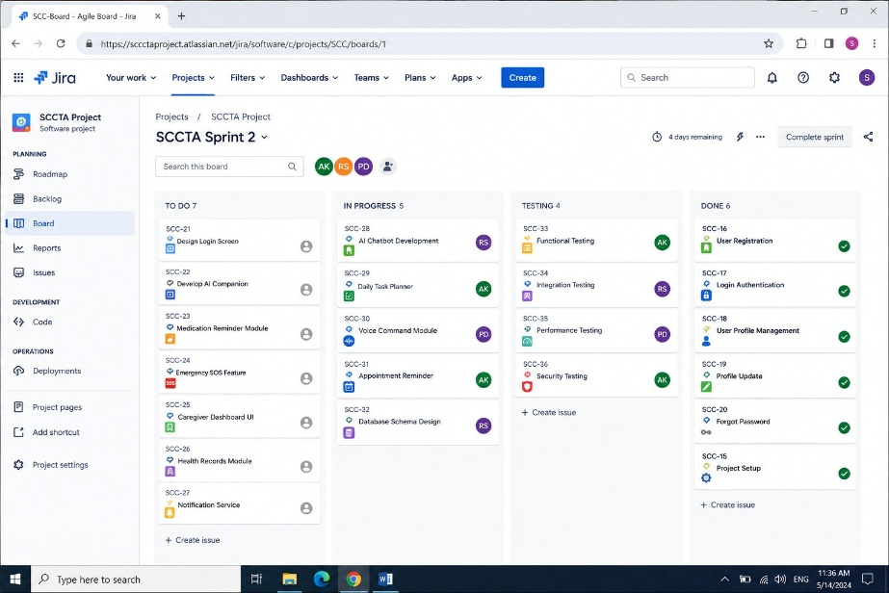

7.2 Confluence
Confluence serves as the documentation repository for the project.
It stores
- Requirement Specification
- Meeting Notes
- API Documentation
- Sprint Reports
- UI Designs
- Database Schema
- Project Timeline
- Testing Reports
Suggested Screenshot
Project Home
↓
Software Requirement Specification
↓
Design Documents
↓
Meeting Minutes
↓
Sprint Documentation
↓
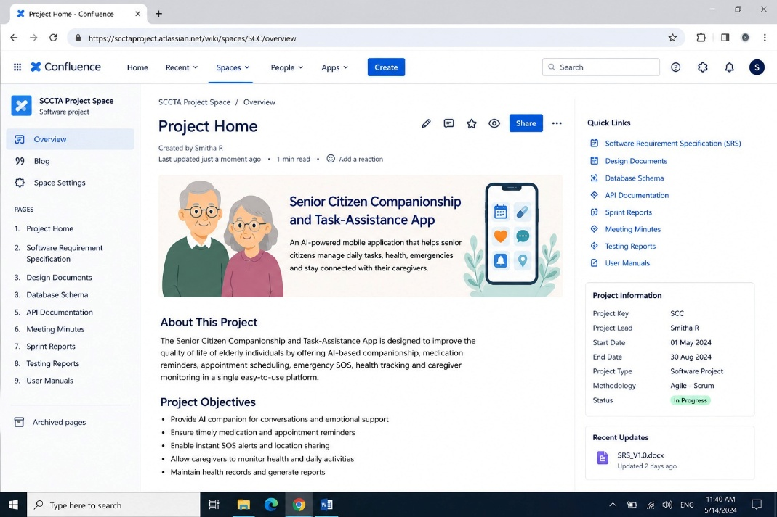
Testing Reports

7.3 Trello
Trello provides visual task management.
Suggested Lists
To Do
- Literature Survey
- Requirement Collection
- UI Design
- Database Design
Doing
- AI Chatbot Development
- Reminder Module
- Health Monitoring Module
Testing
- Functional Testing
- UI Testing
- Security Testing
Completed
- Requirement Analysis
- Project Proposal
- System Design
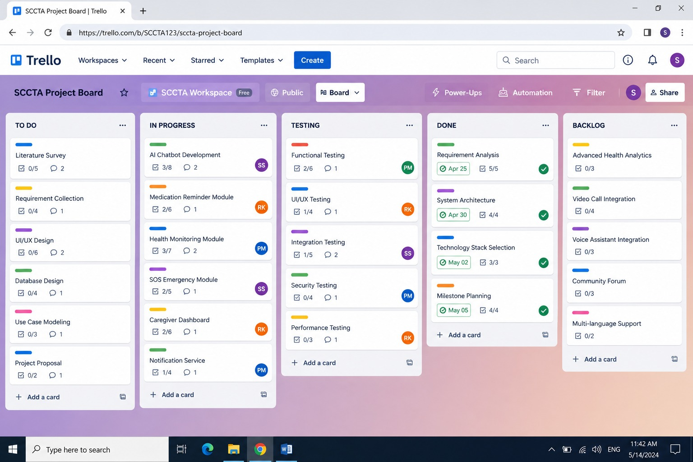

8. Objectives
The primary objectives of the Senior Citizen Companionship and Task-Assistance App are:
OBJ-1
Develop an AI-powered virtual companion that interacts naturally with senior citizens.
OBJ-2
Provide intelligent medication reminders and appointment scheduling.
OBJ-3
Enable emergency SOS notifications with GPS location sharing.
OBJ-4
Allow caregivers and family members to monitor elderly health remotely.
OBJ-5
Provide mood analysis and emotional companionship.
OBJ-6
Maintain secure storage of medical records.
OBJ-7
Promote independent living while ensuring continuous safety.
OBJ-8
Provide voice-based interaction for elderly users.
OBJ-9
Improve communication between senior citizens and caregivers.
OBJ-10
Ensure secure authentication and privacy protection.

9. Scope
In Scope
The application includes:
- User Registration
- Login Authentication
- AI Chat Assistant
- Voice Commands
- Medication Reminder
- Appointment Reminder
- Daily Task Planner
- Water Intake Reminder
- Exercise Reminder
- Emergency SOS
- Live GPS Tracking
- Family Notifications
- Caregiver Dashboard
- Mood Tracking
- Health Monitoring
- Medical History
- Notification Management
- Cloud Database
- Secure Authentication
Out of Scope
The following are excluded from the current version:
- Online doctor consultation
- Medicine delivery service
- Health insurance processing
- Hospital management
- Robotic elderly assistance
- Wearable device manufacturing
- Ambulance dispatch management
- Video-based health diagnosis
- Smart home automation
- Financial management

10. Stakeholder Analysis
Stakeholder | Category | Role | Influence
Senior Citizen | Primary User | Uses the mobile application | High
Family Member | Primary User | Monitors elderly activities | High
Caregiver | Primary User | Assists elderly users | High
Doctor | Secondary User | Reviews medical reports | Medium
Hospital | External | Provides healthcare support | Medium
System Administrator | Technical | Manages users and security | High
Software Developer | Technical | Builds and maintains the application | High
Database Administrator | Technical | Maintains cloud database | Medium
Firebase Services | External System | Authentication & Database | Medium
Google Maps API | External System | Location tracking | Medium

11. Business Requirements
The application shall satisfy the following business requirements.
BR-01
Reduce loneliness among senior citizens through AI-based companionship.
BR-02
Improve medication adherence using intelligent reminders.
BR-03
Reduce emergency response time through SOS alerts.
BR-04
Provide continuous health monitoring.
BR-05
Improve communication between family members and senior citizens.
BR-06
Maintain centralized medical records.
BR-07
Provide secure authentication and privacy.
BR-08
Reduce dependency on caregivers for routine tasks.
BR-09
Support independent living.
BR-10
Provide scalable cloud-based healthcare services.
BR-11
Improve elderly mental well-being.
BR-12
Provide reliable notification delivery.
BR-13
Support multi-user caregiver management.
BR-14
Maintain high application availability.
BR-15
Support future AI enhancements.

12. Functional Requirements
The following functional requirements define the major features of the Senior Citizen Companionship and Task-Assistance App.
ID | Functional Requirement | Priority
FR-01 | The system shall allow users to register using mobile number or email. | High
FR-02 | The system shall authenticate users securely before granting access. | High
FR-03 | The system shall allow users to update their personal profile. | High
FR-04 | The system shall store emergency contact details. | High
FR-05 | The system shall provide AI-based conversational companionship. | High
FR-06 | The system shall support voice-based interaction. | High
FR-07 | The system shall schedule medication reminders. | High
FR-08 | The system shall notify users about doctor appointments. | High
FR-09 | The system shall remind users to drink water. | Medium
FR-10 | The system shall remind users to perform daily exercises. | Medium
FR-11 | The system shall manage daily task schedules. | High
FR-12 | The system shall generate emergency SOS alerts. | High
FR-13 | The system shall share live GPS location during emergencies. | High
FR-14 | The system shall notify caregivers instantly. | High
FR-15 | The system shall notify family members during emergencies. | High
FR-16 | The system shall maintain medical records. | High
FR-17 | The system shall allow caregivers to monitor elderly health information. | High
FR-18 | The system shall store reminder history. | Medium
FR-19 | The system shall monitor user mood using AI analysis. | Medium
FR-20 | The system shall recommend relaxation activities. | Medium
FR-21 | The system shall allow users to view health reports. | Medium
FR-22 | The system shall send notification alerts. | High
FR-23 | The system shall support password recovery. | Medium
FR-24 | The system shall synchronize data with cloud storage. | High
FR-25 | The system shall allow administrators to manage users. | High
FR-26 | The system shall generate activity logs. | Medium
FR-27 | The system shall display caregiver dashboard. | High
FR-28 | The system shall provide multilingual support. | Medium
FR-29 | The system shall provide large-font accessibility mode. | High
FR-30 | The system shall allow profile editing. | Medium
FR-31 | The system shall maintain notification history. | Medium
FR-32 | The system shall maintain appointment history. | Medium
FR-33 | The system shall allow secure logout. | High
FR-34 | The system shall maintain backup of user information. | High
FR-35 | The system shall generate health analytics reports. | Medium

13. Non-Functional Requirements
ID | Category | Requirement | Priority
NFR-01 | Performance | Response time shall be less than 3 seconds. | High
NFR-02 | Availability | System availability shall be 99.5%. | High
NFR-03 | Security | User authentication shall be secure. | High
NFR-04 | Privacy | Personal information shall remain confidential. | High
NFR-05 | Reliability | System shall provide continuous service. | High
NFR-06 | Scalability | System shall support thousands of users. | High
NFR-07 | Maintainability | Software shall be easy to update. | Medium
NFR-08 | Portability | Application shall run on Android devices. | High
NFR-09 | Accessibility | Large text and voice support shall be available. | High
NFR-10 | Compatibility | Compatible with latest Android versions. | Medium
NFR-11 | Backup | Cloud backup shall be automatic. | Medium
NFR-12 | Recovery | Data recovery shall be possible after failures. | Medium
NFR-13 | Integrity | Data shall remain accurate and consistent. | High
NFR-14 | Usability | Interface shall be simple for elderly users. | High
NFR-15 | Localization | Multiple language support shall be available. | Medium
NFR-16 | Notification | Alerts shall be delivered immediately. | High
NFR-17 | Encryption | Sensitive data shall be encrypted. | High
NFR-18 | Cloud Storage | Data shall be stored securely on Firebase. | High
NFR-19 | Logging | User activities shall be logged. | Medium
NFR-20 | Disaster Recovery | Daily cloud backups shall be maintained. | Medium

14. Actors
Actor | Description
Senior Citizen | Primary user who receives reminders, companionship, and assistance.
Family Member | Monitors elderly activities and receives emergency alerts.
Caregiver | Assists senior citizens with health and daily tasks.
Doctor | Reviews health records and treatment information.
System Administrator | Manages users, permissions, and system maintenance.
AI Companion | Virtual assistant providing conversation and guidance.
Firebase Cloud | Stores application data securely.
Google Maps API | Provides GPS location during emergencies.

15. Use Case Diagram

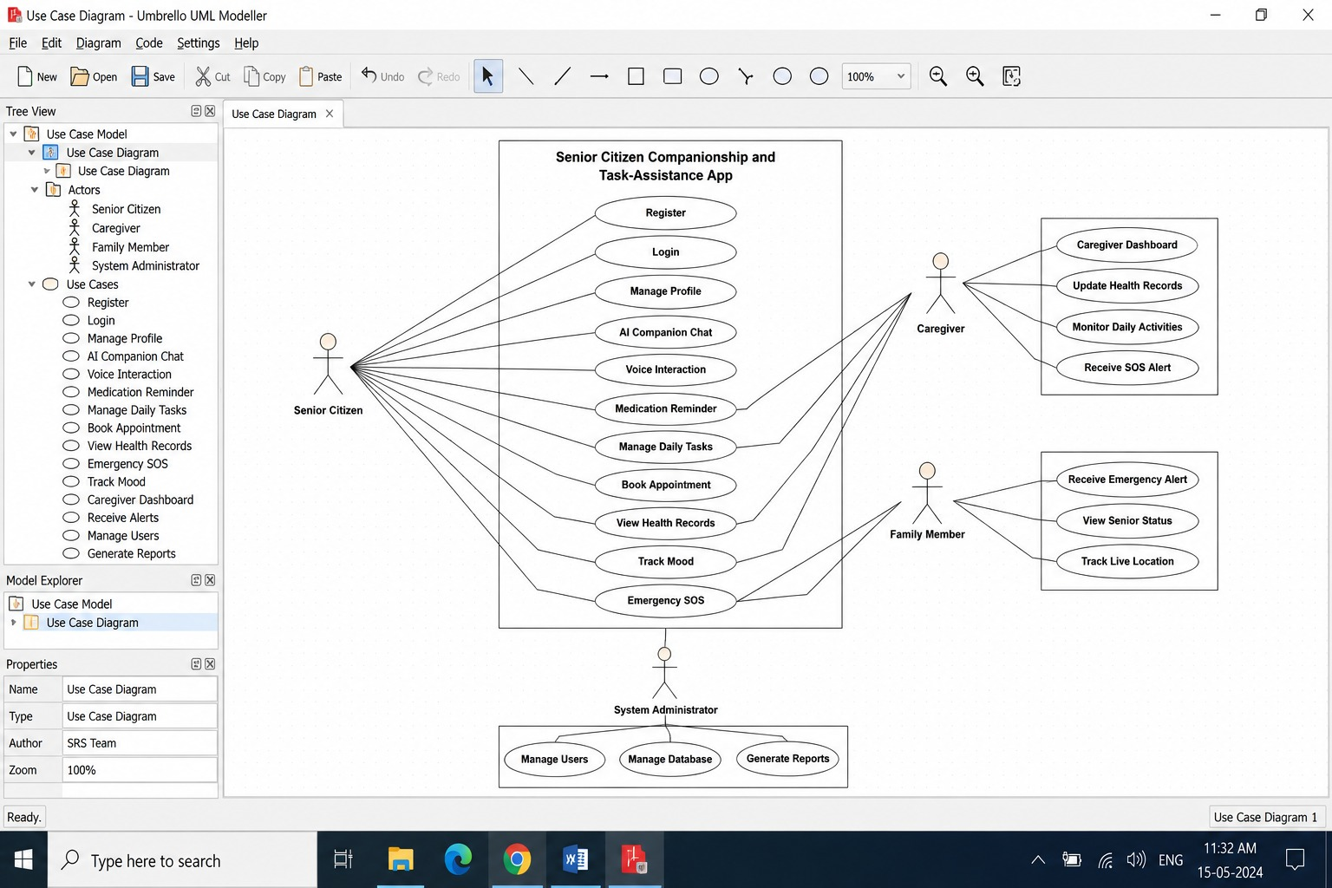

16. Use Case Descriptions
UC-01 User Login
Primary Actor: Senior Citizen
Precondition
User must be registered.
Main Flow
- User enters login credentials.
- System validates credentials.
- Dashboard is displayed.
Postcondition
User is successfully logged into the application.

UC-02 Medication Reminder
Primary Actor
Senior Citizen
Precondition
Medicine schedule is available.
Main Flow
- Reminder time arrives.
- Notification appears.
- User confirms medicine intake.
- System stores reminder history.
Postcondition
Medication status is updated.

UC-03 Emergency SOS
Primary Actor
Senior Citizen
Precondition
Emergency contacts are available.
Main Flow
- User presses SOS button.
- GPS location is collected.
- Notification sent to caregivers.
- Notification sent to family.
- Emergency details are stored.
Postcondition
Emergency alert successfully delivered.

UC-04 AI Companion Chat
Primary Actor
Senior Citizen
Precondition
Internet connection is available.
Main Flow
- User starts conversation.
- AI processes request.
- AI responds.
- Conversation is saved.
Postcondition
Companionship session completed.

UC-05 Caregiver Monitoring
Primary Actor
Caregiver
Precondition
Caregiver is authenticated.
Main Flow
- Login.
- View elderly profile.
- Review reminders.
- Review health records.
- Update health status.
Postcondition
Health information successfully updated

17. Data Requirements
The application stores user, healthcare, reminder, emergency, and activity data securely in Firebase Cloud Firestore.
Field | Data Type | Description | Constraint
User_ID | UUID | Unique user identifier | Primary Key
Name | VARCHAR(100) | Senior citizen name | Not Null
Age | INTEGER | User age | >60
Gender | VARCHAR(20) | Gender | Not Null
Mobile_Number | VARCHAR(15) | Contact number | Unique
Email | VARCHAR(100) | Email address | Unique
Password | VARCHAR(255) | Encrypted password | Not Null
Medical_History | TEXT | Previous illnesses | Optional
Medication_Name | VARCHAR(100) | Medicine details | Not Null
Reminder_Time | TIMESTAMP | Medicine reminder | Not Null
Appointment_Date | DATE | Doctor appointment | Not Null
Mood_Status | VARCHAR(50) | Daily mood | Optional
Activity_Log | TEXT | Daily activities | Optional
Emergency_Contact | VARCHAR(15) | Caregiver number | Not Null
GPS_Location | VARCHAR(100) | Live location | Optional
SOS_Status | BOOLEAN | Emergency status | Default False
Notification_ID | UUID | Notification identifier | Primary Key

Database Tables
- User
- Caregiver
- Medication
- Appointment
- Reminder
- Emergency Contact
- Mood History
- Health Report
- Notification
- Activity Log

18. External Interface Requirements
User Interface
The application provides:
- Elderly-friendly dashboard
- Large buttons
- Large font size
- Voice navigation
- AI Chat Screen
- Reminder Screen
- Emergency SOS Screen
- Health Dashboard
- Caregiver Dashboard
- Settings Page

Hardware Interface
Supported Devices
- Android Smartphones
- Tablets
- GPS Module
- Internet Connectivity
- Microphone
- Speaker
Software Interface
- Android Studio
- Firebase Authentication
- Firebase Firestore
- Firebase Cloud Messaging
- Google Maps API
- Android SDK
Communication Interface
- HTTPS
- Firebase Cloud Messaging
- Internet Connectivity
- GPS Services
- REST APIs

19. Requirement Validation
The following validation activities ensure software quality.
Validation Approach
- Stakeholder Review
- Requirement Inspection
- Prototype Evaluation
- Functional Testing
- Integration Testing
- System Testing
- User Acceptance Testing (UAT)
Validation Checklist
✔ Requirements are complete
✔ Requirements are testable
✔ Requirements are consistent
✔ Requirements are feasible
✔ Requirements satisfy business objectives

20. Risk Analysis

Risk ID | Risk | Impact | Probability | Mitigation
R-01 | Internet Failure | High | Medium | Offline reminder support
R-02 | Firebase Downtime | High | Low | Cloud backup
R-03 | GPS Failure | Medium | Low | Network location fallback
R-04 | Notification Delay | Medium | Medium | Retry mechanism
R-05 | Data Breach | High | Low | Data encryption
R-06 | Unauthorized Access | High | Low | Two-factor authentication
R-07 | Elderly unfamiliar with app | Medium | High | Simple UI & training
R-08 | Device Battery Drain | Medium | Medium | Optimized background services
R-09 | Lost Mobile Device | Medium | Medium | Secure login & remote logout
R-10 | Server Failure | High | Low | Automatic cloud recovery

21. Requirement Traceability Matrix (RTM)
Requirement | Objective | Use Case | Test Case
FR-05 AI Companion | OBJ-01 | UC-04 | TC-01
FR-07 Medicine Reminder | OBJ-02 | UC-02 | TC-02
FR-12 Emergency SOS | OBJ-03 | UC-03 | TC-03
FR-17 Caregiver Dashboard | OBJ-04 | UC-05 | TC-04
FR-19 Mood Detection | OBJ-05 | UC-04 | TC-05
FR-22 Notification | OBJ-06 | UC-02 | TC-06
FR-24 Cloud Storage | OBJ-07 | UC-01 | TC-07
FR-29 Accessibility Mode | OBJ-08 | UC-01 | TC-08
FR-34 Data Backup | OBJ-09 | UC-05 | TC-09
NFR-03 Security | OBJ-10 | UC-01 | TC-10

22. Requirement Prioritization (MoSCoW)
Must Have
- User Registration
- Login
- AI Companion
- Medication Reminder
- Appointment Reminder
- Emergency SOS
- GPS Tracking
- Caregiver Dashboard
- Notifications

Should Have
- Mood Detection
- Voice Commands
- Daily Task Planner
- Water Reminder
- Exercise Reminder
- Health Reports

Could Have
- Health Prediction
- Smartwatch Integration
- Diet Recommendation
- Video Calling
- Smart Home Integration

Won't Have (Current Version)
- Online Pharmacy
- Ambulance Booking
- Hospital Management
- Insurance Processing
- Robotic Assistance

23. Future Enhancements
The application can be extended with advanced features in future versions.
- Smartwatch Integration
- AI Health Prediction
- Fall Detection using Sensors
- ECG Monitoring
- Blood Pressure Monitoring
- Blood Sugar Monitoring
- Doctor Video Consultation
- Medicine Delivery Integration
- Voice Assistant in Regional Languages
- Smart Home Device Control
- Face Recognition Login
- Wearable Device Integration
- AI Depression Detection
- Personalized Health Recommendations
- Family Health Dashboard
- Cloud Analytics
- AI Nutrition Suggestions
- Smart Calendar Integration
- Emergency Ambulance Integration
- Offline AI Assistant

24. Conclusion
The Senior Citizen Companionship and Task-Assistance App is designed to improve the safety, health, and emotional well-being of elderly individuals by combining AI-powered companionship with healthcare and daily task management.
The application enables medication reminders, appointment scheduling, emergency SOS alerts, caregiver monitoring, voice assistance, and health record management through a simple and user-friendly interface. It promotes independent living while ensuring that caregivers and family members remain connected and informed.
The proposed system offers a secure, scalable, and reliable solution that addresses both healthcare and emotional support needs of senior citizens. With future enhancements such as wearable integration, AI health prediction, and smart home connectivity, the platform can evolve into a comprehensive digital healthcare ecosystem.

